Project 14

Selection of Text
For most text related objects it is often useful to be able to take a selection of the text or part of the text from the text part and highlight the text. Both the text box and the combo can use the following properties to read or write a value of the selected text. In the table below a list the different properties used with the selection of text. Each of the examples assumes an object before the dot In the example.

Property | Sets | Example Write | Example Read
SelStart | Start of the selected text | .SelStart=0  Start at first character | begins =.SelStart  Read start position of selected text.
SelLength | length of selected text | .SelLength = 2  Set the highlighted text to be 2 characters. | length = .SelLength  read length of selected text
SelText | The text that is selected | .SelText = “Aa”  Replaces all the selected text with “Aa” | Text1.text = .SelText  Reads the selected text into text1 text box.

Form Design and Layout
The code that follows has been written for text boxes but the same code could be modified for combo boxes or some other text type object.
Add four text boxes with only one of those text boxes unlocked so that text may only be entered into textbox 1. Set the multiple line property to true for all text boxes. Add three command buttons.
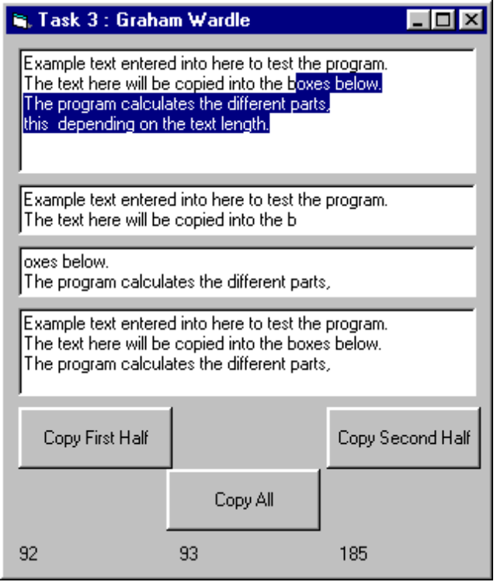

Code
For each of the three command buttons add the following code the click events.
Option Explicit
Private Sub CommandCopy1_Click()
Text1.SelStart = 0
Text1.SelLength = Len(Text1.Text) / 2
Label1.Caption = Text1.SelLength
Text2.Text = Text1.SelText
Text1.SetFocus
End Sub
Private Sub CommandCopy2_Click()
Text1.SelStart = (Len(Text1.Text) / 2)
Text1.SelLength = Len(Text1.Text) - (Len(Text1.Text) / 2) + 1
Label2.Caption = Text1.SelLength
Text3.Text = Text1.SelText
Text1.SetFocus
End Sub
Private Sub CommandCopyAll_Click()
Text1.SelStart = 0
Text1.SelLength = Len(Text1.Text)
Label3.Caption = Text1.SelLength
Text4.Text = Text1.SelText
Text1.SetFocus
End Sub

Exercise
Write a program that does find text and replaces text in a text box. The program should take the text used for search from a text box. The replacement text also should be taken from a text box. If the program finds a match the text should be highlighted and then on the prompt of a message box replace the highlighted text with that of the replacement text from a text box.
Hint for showing the selection of the selected text while the text box does not have the focus (i.e. when the message box is waiting for a Yes or No) look at using the property HideSelection for the text box.

